Computer Architecture Lab
(EL-2012)
LABORATORY REPORT

Fall 2026

(Lab#03)
Apply Behavioral-level Verilog to Design and Simulate Combinational Modules

Student Name: _Syed Sikandar Abbas_ Roll No: _24I-6553_ Section: CE-3B

Date performed: _September 2, 2026

MARKS AWARDED: ________ / 10

Signature and date of Instructor: _________________
Lab Instructors: Dr. Nasir Ali Shah, Engr. Fasih Ahmad

______________________________________________________________________________________________________________________________________________________

NATIONAL UNIVERSITY OF COMPUTER AND EMERGING SCIENCES, ISLAMABAD
Prepared by: | Fasih Ahmad |  | Version: 1.0
Verified by: | Dr. Nasir Ali Shah |  | Updated: Fall 2026

Task 1:

Description:
In this task I was intended to make a behavioral circuit in Verilog for an Adder/Subtractor based on a control Signal. It takes two inputs I0 and I1 and performs either Addition (if Signal is 0) or Subtraction (if Signal is 1). The output was stored in 5 bits because if the user was to add maximum 4 bit numbers (say 1111 + 1111) it was to give us a 5-bit number (11110). It uses built in + and – operators to perform addition and subtraction.
Code:
module Adder_Subtractor(I0, I1, Signal, Output);

input [3:0] I0;
input [3:0] I1;
input Signal;
output reg [4:0] Output;

always @(*)
begin
if (Signal == 0)
Output = I0 + I1;
else
Output = I0 - I1;
ende

endmodule

module T1_testbench();

reg [3:0] I0;
reg [3:0] I1;
reg signal;
wire [4:0] op;

Adder_Subtractor myAddSub(I0, I1, signal, op);

initial
begin
I0 = 0; I1 = 5; signal = 0;
#10 I0 = 2; I1 = 4; signal = 0;
#10 I0 = 9; I1 = 5; signal = 0;
#10 I0 = 2; I1 = 7; signal = 0;
#10 I0 = 7; I1 = 5; signal = 1;
#10 I0 = 15; I1 = 4; signal = 1;
#10 I0 = 14; I1 = 6; signal = 1;
#10 I0 = 8; I1 = 8; signal = 1;
end

endmodule
Output:
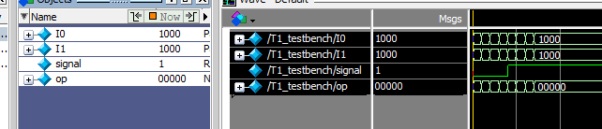

Task 2:

Description:
In this task we were supposed to build a multiplexer module that assigns A & B to the output when the Control Signal or Selection Line is 0 otherwise assign A | B to the Output. This was achieved by using Behavioural level modelling in Verilog and writing always @ * which means for every change in value the iteration will run again.
Code:
module _2to1Mux(I0, I1, S, O);
input I0;
input I1;
input S;
output reg O;

always @ (*)
begin
if (S == 0)
O = I0 & I1;
else
O = I0 | I1;
end

endmodule

module T2_testbench();

reg A;
reg B;
reg S;
wire Op;

_2to1Mux mux(A, B, S, Op);

initial
begin
A = 0; B = 0; S = 0;
#10 A = 0; B = 0; S = 1;
#10 A = 0; B = 1; S = 0;
#10 A = 0; B = 1; S = 1;
#10 A = 1; B = 0; S = 0;
#10 A = 1; B = 0; S = 1;
#10 A = 1; B = 1; S = 0;
#10 A = 1; B = 1; S = 1;
end

endmodule
Output:
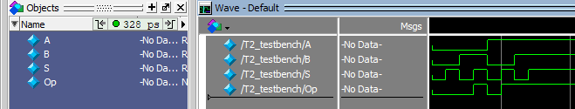

Task 3:

Description:
In this task we were supposed to build a comparator module that has three outputs, eq, gr and ls. It takes two 2-bit inputs and if the first one is equal to the second one, eq output goes high and all the other go low. If the first one is greater than 2nd one, then gr goes high, eq and ls go low. Else (when first one is lower and second one is greater) then eq and gr go low while ls goes high. The module was then simulated using testbench.
Code:
module comparator(I0, I1, eq, gr, ls);

input [1:0] I0;
input [1:0] I1;
output reg eq;
output reg gr;
output reg ls;

always @ *
begin
if (I0 > I1)
begin
eq = 0;
gr = 1;
ls = 0;
end
else if (I0 == I1)
begin
eq = 1;
gr = 0;
ls = 0;
end
else
begin
eq = 0;
gr = 0;
ls = 1;
end

end

endmodule

module T3_testbench();

reg [1:0] A;
reg [1:0] B;
wire eq, gr, ls;

comparator comp(A, B, eq, gr, ls);

initial
begin
A = 0; B = 0;
#10 A = 1; B = 0;
#10 A = 2; B = 3;
end

endmodule
Output:
